

ASSET VERIFICATION AND RECORDING TOOL KIT


Plot 31, Bukoto Street
P.O Box 7657, Kampala, Uganda
+256 (0) 39 2000216/0772525235
email: cpa@cpa.ug

www.cpa.com

August to September 2026

VERIFICATION DETAILS

NAME OF THE REGION:
SUB-REGION:
Name of Local Government
VERIFIER PARTICULARS
Full name
Contact/ email and Telephone
Supervisor/ Sub team leader
Name

Contact
Date of submission

HEALTH CENTRES
INFORMANT INTERVIEW/DISCUSSION GUIDE (INCHARGE OR RESPONSIBLE PERSON)

Name of Health Centre: ………………………………………………………………………………..

1a | Does the Facility have a record of all assets provided under UgIFT.  (Obtain a record and verify if it has the costs and numbers supplied
1b | If Not ask how many were supplied and when.

2 | How does this facility Maintain (repair/service/replace) the assets provided under Ugift

3 | Does the facility take regular record about functionality/ or breakdown of the assets provided?

4 | How has the UgIFT support helped in service delivery in the area, any issues, challenges and any recommendations for better program implementation.

PROCEED TO VERIFICATION AFTER THIS DISCUSSION

Health centre checklist

NAME OF LG; ………………………………………………………………………NAME OF HEALTH FACILITY: ………………………………………………………………………………………….

Equipment/ Item | Department | Asset Number | Item  Description | Life in Months | Tag Number ( engrave no.) | Date Of Purchase | Date Placed In Service | Recoverable cost | Cost | Acc Dep Cost | Net Book Value | Ytd Deprn | Equipment status | Remarks
B.P. Machine, Digital
B.P. Machine (Aneroid wall mounted)
Autoclave 20 Liters.,Duo Operated
Bowl, Kick
Bowl Stand
Counting chamber Neubauer- Improved
Cupboard Steel, Lockable
Drip Stand
ESR Stand
Examination Couch
Examination light,LED
Glucometer
Haemoglobin Meter, Digital
Height Meter
Instrument Trolley
Microscope Binocular
Otoscope
Patient Screen
Patient Trolley
Refrigerator, Basic
Stethoscope
Stop Watch
Stretcher
Stove, Gas
Weighing Scale with Height Meter, Adult
Weighing Scale, Infant
Weighing Scale, Toddler
Wheel Chair
Audio Visual Equipment
Medical Waste Bin
Wall Clock
Diagnostic Equipment Set for MCH
Diagnostic Equipment Set for OPD
Glassware Set, Laboratory, Basic
Hollow Ware Set, Treatment
Instrument Set, Dressing
Instrument Set, Basic ENT
Instrument Set, Suture
Pulse Oximeter, Hand held
Bed, Adult Patient with Mattress
Bed, Pediatric Patient, With Mattress
Bedside Locker
Cupboard, Instrument
Delivery Bed, Hydraulic Manual
Oxygen Therapy Apparatus, Mininum 45L cylinder
Resuscitator Manual, Infant, with all Mask sizes
Resuscitator Manual, Adult, with all mask sizes
Suction Apparatus, (Electric)
Nebulizer, Ultrasonic
Oxygen Concentrator, Duo Flow
Bench
Disinfection Buckets
Baby Cot
Diagnostic Equipment Set for Ward
Hollow Ware Set, Ward
Instrument Set, Delivery
Instrument Set, Stitch Removing
MVA Kit
Stool, Laboratory
Penguin Sucker
Fetoscope, Dopplar
Bubble CPAP
Centrifuge (Electric)
Kangaroo Mother Care Chair
Radiant Infant Warmer
Haemoglobin Meter, Sahli
Delivery Bed
Examination light
Instrument set, ENT Basic for HCIII
Bag Valve mask (Ambu Bag), Neonatal
Incubator
Office Chair
Desk
Filing Cabinet
Non Residential Buildings
Residential Buildings

SCHOOL VERIFICATION CHECKLIST

SCHOOL INTERVIEW/DISCUSSION GUIDE

Name of school: WAMATOVU SEED SEED SECONDARY SCHOOL
1a | Does the Facility have a record of all assets provided under UgIFT.  (Obtain a record and verify if it has the costs and numbers supplied | Yes
1b | If Not ask how many were supplied and when.

2 | How does this facility Maintain (repair/service/replace) the assets provided under Ugift

3 | Does the facility take regular record about functionality/ or breakdown of the assets provided?  Nonfunctional/ working, and reasons for non-functionality. | Yes

4 | How has the UgIFT support helped in service delivery in the area, any issues, challenges and any recommendations for better program implementation.

PROCEED TO VERIFICATION AFTER THIS DISCUSSION

SCHOOL FURNITURE
(School Desks, Office chairs, Laboratory stools, Book shelves)

Name of LG: MPIGI LOCAL GOVERNMENT
Name of SCHOOL: WAMATOVU SEED SECONDARY SCHOOL

EQUPMENT | DEPARTMENT | ASSET NUMBER | ITEM DESCRIPTION | LIFE IN MONTHS | TAG NUMBER (engrave no) | Date of Purchase | Date placed in service | cost | Recovery cost | Acc Dep cost | Net book value | Ytd Deprn | Equipment status | remarks
DESK | EDUCATION |  | WOODEN |  | Ugift/WAMATOVU SEED S.S OFFICE DESK 001 |  | 11-Apr-22 |  |  |  |  |  | Good
DESK | EDUCATION |  | WOODEN |  | Ugift/WAMATOVU SEED S.S OFFICE DESK 002 |  | 11-Apr-22 |  |  |  |  |  | Good
DESK | EDUCATION |  | WOODEN |  | Ugift/WAMATOVU SEED S.S OFFICE DESK 003 |  | 11-Apr-22 |  |  |  |  |  | Good
DESK | EDUCATION |  | WOODEN |  | Ugift/WAMATOVU SEED S.S OFFICE DESK 004 |  | 11-Apr-22 |  |  |  |  |  | Good
DESK | EDUCATION |  | WOODEN |  | Ugift/WAMATOVU SEED S.S OFFICE DESK 005 |  | 11-Apr-22 |  |  |  |  |  | Good
DESK | EDUCATION |  | WOODEN |  | Ugift/WAMATOVU SEED S.S OFFICE DESK 006 |  | 11-Apr-22 |  |  |  |  |  | Good
DESK | EDUCATION |  | WOODEN |  | Ugift/WAMATOVU SEED S.S OFFICE DESK 007 |  | 11-Apr-22 |  |  |  |  |  | Good
DESK | EDUCATION |  | WOODEN |  | Ugift/WAMATOVU SEED S.S OFFICE DESK 008 |  | 11-Apr-22 |  |  |  |  |  | Good
DESK | EDUCATION |  | WOODEN |  | Ugift/WAMATOVU SEED S.S OFFICE DESK 009 |  | 11-Apr-22 |  |  |  |  |  | Good
DESK | EDUCATION |  | WOODEN |  | Ugift/WAMATOVU SEED S.S OFFICE DESK 010 |  | 11-Apr-22 |  |  |  |  |  | Good
DESK | EDUCATION |  | WOODEN |  | Ugift/WAMATOVU SEED S.S OFFICE DESK 011 |  | 11-Apr-22 |  |  |  |  |  | Good
DESK | EDUCATION |  | WOODEN |  | Ugift/WAMATOVU SEED S.S OFFICE DESK 012 |  | 11-Apr-22 |  |  |  |  |  | Good
DESK | EDUCATION |  | WOODEN |  | Ugift/WAMATOVU SEED S.S OFFICE DESK 013 |  | 11-Apr-22 |  |  |  |  |  | Good
DESK | EDUCATION |  | WOODEN |  | Ugift/WAMATOVU SEED S.S OFFICE DESK 014 |  | 11-Apr-22 |  |  |  |  |  | Good
DESK | EDUCATION |  | WOODEN |  | Ugift/WAMATOVU SEED S.S OFFICE DESK 015 |  | 11-Apr-22 |  |  |  |  |  | Good
DESK | EDUCATION |  | WOODEN |  | Ugift/WAMATOVU SEED S.S OFFICE DESK 016 |  | 11-Apr-22 |  |  |  |  |  | Good
DESK | EDUCATION |  | WOODEN |  | Ugift/WAMATOVU SEED S.S OFFICE DESK 017 |  | 11-Apr-22 |  |  |  |  |  | Good
DESK | EDUCATION |  | WOODEN |  | Ugift/WAMATOVU SEED S.S OFFICE DESK 018 |  | 11-Apr-22 |  |  |  |  |  | Good
DESK | EDUCATION |  | WOODEN |  | Ugift/WAMATOVU SEED S.S OFFICE DESK 019 |  | 11-Apr-22 |  |  |  |  |  | Good
DESK | EDUCATION |  | WOODEN |  | Ugift/WAMATOVU SEED S.S OFFICE DESK 020 |  | 11-Apr-22 |  |  |  |  |  | Good
DESK | EDUCATION |  | WOODEN |  | Ugift/WAMATOVU SEED S.S OFFICE DESK 021 |  | 11-Apr-22 |  |  |  |  |  | Good
DESK | EDUCATION |  | WOODEN |  | Ugift/WAMATOVU SEED S.S OFFICE DESK 022 |  | 11-Apr-22 |  |  |  |  |  | Good
DESK | EDUCATION |  | WOODEN |  | Ugift/WAMATOVU SEED S.S OFFICE DESK 023 |  | 11-Apr-22 |  |  |  |  |  | Good
DESK | EDUCATION |  | WOODEN |  | Ugift/WAMATOVU SEED S.S OFFICE DESK 024 |  | 11-Apr-22 |  |  |  |  |  | Good
DESK | EDUCATION |  | WOODEN |  | Ugift/WAMATOVU SEED S.S OFFICE DESK 025 |  | 11-Apr-22 |  |  |  |  |  | Good
DESK | EDUCATION |  | WOODEN |  | Ugift/WAMATOVU SEED S.S OFFICE DESK 026 |  | 11-Apr-22 |  |  |  |  |  | Good
DESK | EDUCATION |  | WOODEN |  | Ugift/WAMATOVU SEED S.S OFFICE DESK 027 |  | 11-Apr-22 |  |  |  |  |  | Good
DESK | EDUCATION |  | WOODEN |  | Ugift/WAMATOVU SEED S.S OFFICE DESK 028 |  | 11-Apr-22 |  |  |  |  |  | Good
DESK | EDUCATION |  | WOODEN |  | Ugift/WAMATOVU SEED S.S OFFICE DESK 029 |  | 11-Apr-22 |  |  |  |  |  | Good
DESK | EDUCATION |  | WOODEN |  | Ugift/WAMATOVU SEED S.S OFFICE DESK 030 |  | 11-Apr-22 |  |  |  |  |  | Good
DESK | EDUCATION |  | WOODEN |  | Ugift/WAMATOVU SEED S.S OFFICE DESK 031 |  | 11-Apr-22 |  |  |  |  |  | Good
DESK | EDUCATION |  | WOODEN |  | Ugift/WAMATOVU SEED S.S OFFICE DESK 032 |  | 11-Apr-22 |  |  |  |  |  | Good
DESK | EDUCATION |  | WOODEN |  | Ugift/WAMATOVU SEED S.S OFFICE DESK 033 |  | 11-Apr-22 |  |  |  |  |  | Good
DESK | EDUCATION |  | WOODEN |  | Ugift/WAMATOVU SEED S.S OFFICE DESK 034 |  | 11-Apr-22 |  |  |  |  |  | Good
DESK | EDUCATION |  | WOODEN |  | Ugift/WAMATOVU SEED S.S OFFICE DESK 035 |  | 11-Apr-22 |  |  |  |  |  | Good
DESK | EDUCATION |  | WOODEN |  | Ugift/WAMATOVU SEED S.S OFFICE DESK 036 |  | 11-Apr-22 |  |  |  |  |  | Good
DESK | EDUCATION |  | WOODEN |  | Ugift/WAMATOVU SEED S.S OFFICE DESK 037 |  | 11-Apr-22 |  |  |  |  |  | Good
DESK | EDUCATION |  | WOODEN |  | Ugift/WAMATOVU SEED S.S OFFICE DESK 038 |  | 11-Apr-22 |  |  |  |  |  | Good
DESK | EDUCATION |  | WOODEN |  | Ugift/WAMATOVU SEED S.S OFFICE DESK 039 |  | 11-Apr-22 |  |  |  |  |  | Good
DESK | EDUCATION |  | WOODEN |  | Ugift/WAMATOVU SEED S.S OFFICE DESK 040 |  | 11-Apr-22 |  |  |  |  |  | Good
DESK | EDUCATION |  | WOODEN |  | Ugift/WAMATOVU SEED S.S OFFICE DESK 041 |  | 11-Apr-22 |  |  |  |  |  | Good
DESK | EDUCATION |  | WOODEN |  | Ugift/WAMATOVU SEED S.S OFFICE DESK 042 |  | 11-Apr-22 |  |  |  |  |  | Good
DESK | EDUCATION |  | WOODEN |  | Ugift/WAMATOVU SEED S.S OFFICE DESK 043 |  | 11-Apr-22 |  |  |  |  |  | Good
DESK | EDUCATION |  | WOODEN |  | Ugift/WAMATOVU SEED S.S OFFICE DESK 044 |  | 11-Apr-22 |  |  |  |  |  | Good
DESK | EDUCATION |  | WOODEN |  | Ugift/WAMATOVU SEED S.S OFFICE DESK 045 |  | 11-Apr-22 |  |  |  |  |  | Good
DESK | EDUCATION |  | WOODEN |  | Ugift/WAMATOVU SEED S.S OFFICE DESK 046 |  | 11-Apr-22 |  |  |  |  |  | Good
DESK | EDUCATION |  | WOODEN |  | Ugift/WAMATOVU SEED S.S OFFICE DESK 047 |  | 11-Apr-22 |  |  |  |  |  | Good
DESK | EDUCATION |  | WOODEN |  | Ugift/WAMATOVU SEED S.S OFFICE DESK 048 |  | 11-Apr-22 |  |  |  |  |  | Good
DESK | EDUCATION |  | WOODEN |  | Ugift/WAMATOVU SEED S.S OFFICE DESK 049 |  | 11-Apr-22 |  |  |  |  |  | Good
DESK | EDUCATION |  | WOODEN |  | Ugift/WAMATOVU SEED S.S OFFICE DESK 050 |  | 11-Apr-22 |  |  |  |  |  | Good
DESK | EDUCATION |  | WOODEN |  | Ugift/WAMATOVU SEED S.S OFFICE DESK 051 |  | 11-Apr-22 |  |  |  |  |  | Good
DESK | EDUCATION |  | WOODEN |  | Ugift/WAMATOVU SEED S.S OFFICE DESK 052 |  | 11-Apr-22 |  |  |  |  |  | Good
DESK | EDUCATION |  | WOODEN |  | Ugift/WAMATOVU SEED S.S OFFICE DESK 053 |  | 11-Apr-22 |  |  |  |  |  | Good
DESK | EDUCATION |  | WOODEN |  | Ugift/WAMATOVU SEED S.S OFFICE DESK 054 |  | 11-Apr-22 |  |  |  |  |  | Good
DESK | EDUCATION |  | WOODEN |  | Ugift/WAMATOVU SEED S.S OFFICE DESK 055 |  | 11-Apr-22 |  |  |  |  |  | Good
DESK | EDUCATION |  | WOODEN |  | Ugift/WAMATOVU SEED S.S OFFICE DESK 056 |  | 11-Apr-22 |  |  |  |  |  | Good
DESK | EDUCATION |  | WOODEN |  | Ugift/WAMATOVU SEED S.S OFFICE DESK 057 |  | 11-Apr-22 |  |  |  |  |  | Good
DESK | EDUCATION |  | WOODEN |  | Ugift/WAMATOVU SEED S.S OFFICE DESK 058 |  | 11-Apr-22 |  |  |  |  |  | Good
DESK | EDUCATION |  | WOODEN |  | Ugift/WAMATOVU SEED S.S OFFICE DESK 059 |  | 11-Apr-22 |  |  |  |  |  | Good
DESK | EDUCATION |  | WOODEN |  | Ugift/WAMATOVU SEED S.S OFFICE DESK 060 |  | 11-Apr-22 |  |  |  |  |  | Good
DESK | EDUCATION |  | WOODEN |  | Ugift/WAMATOVU SEED S.S OFFICE DESK 061 |  | 11-Apr-22 |  |  |  |  |  | Good
DESK | EDUCATION |  | WOODEN |  | Ugift/WAMATOVU SEED S.S OFFICE DESK 062 |  | 11-Apr-22 |  |  |  |  |  | Good
DESK | EDUCATION |  | WOODEN |  | Ugift/WAMATOVU SEED S.S OFFICE DESK 063 |  | 11-Apr-22 |  |  |  |  |  | Good
DESK | EDUCATION |  | WOODEN |  | Ugift/WAMATOVU SEED S.S OFFICE DESK 064 |  | 11-Apr-22 |  |  |  |  |  | Good
DESK | EDUCATION |  | WOODEN |  | Ugift/WAMATOVU SEED S.S OFFICE DESK 065 |  | 11-Apr-22 |  |  |  |  |  | Good
DESK | EDUCATION |  | WOODEN |  | Ugift/WAMATOVU SEED S.S OFFICE DESK 066 |  | 11-Apr-22 |  |  |  |  |  | Good
DESK | EDUCATION |  | WOODEN |  | Ugift/WAMATOVU SEED S.S OFFICE DESK 067 |  | 11-Apr-22 |  |  |  |  |  | Good
DESK | EDUCATION |  | WOODEN |  | Ugift/WAMATOVU SEED S.S OFFICE DESK 068 |  | 11-Apr-22 |  |  |  |  |  | Good
DESK | EDUCATION |  | WOODEN |  | Ugift/WAMATOVU SEED S.S OFFICE DESK 069 |  | 11-Apr-22 |  |  |  |  |  | Good
DESK | EDUCATION |  | WOODEN |  | Ugift/WAMATOVU SEED S.S OFFICE DESK 070 |  | 11-Apr-22 |  |  |  |  |  | Good
DESK | EDUCATION |  | WOODEN |  | Ugift/WAMATOVU SEED S.S OFFICE DESK 071 |  | 11-Apr-22 |  |  |  |  |  | Good
DESK | EDUCATION |  | WOODEN |  | Ugift/WAMATOVU SEED S.S OFFICE DESK 072 |  | 11-Apr-22 |  |  |  |  |  | Good
DESK | EDUCATION |  | WOODEN |  | Ugift/WAMATOVU SEED S.S OFFICE DESK 073 |  | 11-Apr-22 |  |  |  |  |  | Good
DESK | EDUCATION |  | WOODEN |  | Ugift/WAMATOVU SEED S.S OFFICE DESK 074 |  | 11-Apr-22 |  |  |  |  |  | Good
DESK | EDUCATION |  | WOODEN |  | Ugift/WAMATOVU SEED S.S OFFICE DESK 075 |  | 11-Apr-22 |  |  |  |  |  | Good
DESK | EDUCATION |  | WOODEN |  | Ugift/WAMATOVU SEED S.S OFFICE DESK 076 |  | 11-Apr-22 |  |  |  |  |  | Good
DESK | EDUCATION |  | WOODEN |  | Ugift/WAMATOVU SEED S.S OFFICE DESK 077 |  | 11-Apr-22 |  |  |  |  |  | Good
DESK | EDUCATION |  | WOODEN |  | Ugift/WAMATOVU SEED S.S OFFICE DESK 078 |  | 11-Apr-22 |  |  |  |  |  | Good
DESK | EDUCATION |  | WOODEN |  | Ugift/WAMATOVU SEED S.S OFFICE DESK 079 |  | 11-Apr-22 |  |  |  |  |  | Good
DESK | EDUCATION |  | WOODEN |  | Ugift/WAMATOVU SEED S.S OFFICE DESK 080 |  | 11-Apr-22 |  |  |  |  |  | Good
DESK | EDUCATION |  | WOODEN |  | Ugift/WAMATOVU SEED S.S OFFICE DESK 081 |  | 11-Apr-22 |  |  |  |  |  | Good
DESK | EDUCATION |  | WOODEN |  | Ugift/WAMATOVU SEED S.S OFFICE DESK 082 |  | 11-Apr-22 |  |  |  |  |  | Good
DESK | EDUCATION |  | WOODEN |  | Ugift/WAMATOVU SEED S.S OFFICE DESK 083 |  | 11-Apr-22 |  |  |  |  |  | Good
DESK | EDUCATION |  | WOODEN |  | Ugift/WAMATOVU SEED S.S OFFICE DESK 084 |  | 11-Apr-22 |  |  |  |  |  | Good
DESK | EDUCATION |  | WOODEN |  | Ugift/WAMATOVU SEED S.S OFFICE DESK 085 |  | 11-Apr-22 |  |  |  |  |  | Good
DESK | EDUCATION |  | WOODEN |  | Ugift/WAMATOVU SEED S.S OFFICE DESK 086 |  | 11-Apr-22 |  |  |  |  |  | Good
DESK | EDUCATION |  | WOODEN |  | Ugift/WAMATOVU SEED S.S OFFICE DESK 087 |  | 11-Apr-22 |  |  |  |  |  | Good
DESK | EDUCATION |  | WOODEN |  | Ugift/WAMATOVU SEED S.S OFFICE DESK 088 |  | 11-Apr-22 |  |  |  |  |  | Good
DESK | EDUCATION |  | WOODEN |  | Ugift/WAMATOVU SEED S.S OFFICE DESK 089 |  | 11-Apr-22 |  |  |  |  |  | Good
DESK | EDUCATION |  | WOODEN |  | Ugift/WAMATOVU SEED S.S OFFICE DESK 090 |  | 11-Apr-22 |  |  |  |  |  | Good
DESK | EDUCATION |  | WOODEN |  | Ugift/WAMATOVU SEED S.S OFFICE DESK 091 |  | 11-Apr-22 |  |  |  |  |  | Good
DESK | EDUCATION |  | WOODEN |  | Ugift/WAMATOVU SEED S.S OFFICE DESK 092 |  | 11-Apr-22 |  |  |  |  |  | Good
DESK | EDUCATION |  | WOODEN |  | Ugift/WAMATOVU SEED S.S OFFICE DESK 093 |  | 11-Apr-22 |  |  |  |  |  | Good
DESK | EDUCATION |  | WOODEN |  | Ugift/WAMATOVU SEED S.S OFFICE DESK 094 |  | 11-Apr-22 |  |  |  |  |  | Good
DESK | EDUCATION |  | WOODEN |  | Ugift/WAMATOVU SEED S.S OFFICE DESK 095 |  | 11-Apr-22 |  |  |  |  |  | Good
DESK | EDUCATION |  | WOODEN |  | Ugift/WAMATOVU SEED S.S OFFICE DESK 096 |  | 11-Apr-22 |  |  |  |  |  | Good
DESK | EDUCATION |  | WOODEN |  | Ugift/WAMATOVU SEED S.S OFFICE DESK 097 |  | 11-Apr-22 |  |  |  |  |  | Good
DESK | EDUCATION |  | WOODEN |  | Ugift/WAMATOVU SEED S.S OFFICE DESK 098 |  | 11-Apr-22 |  |  |  |  |  | Good
DESK | EDUCATION |  | WOODEN |  | Ugift/WAMATOVU SEED S.S OFFICE DESK 099 |  | 11-Apr-22 |  |  |  |  |  | Good
DESK | EDUCATION |  | WOODEN |  | Ugift/WAMATOVU SEED S.S OFFICE DESK 100 |  | 11-Apr-22 |  |  |  |  |  | Good
DESK | EDUCATION |  | WOODEN |  | Ugift/WAMATOVU SEED S.S OFFICE DESK 101 |  | 11-Apr-22 |  |  |  |  |  | Good
DESK | EDUCATION |  | WOODEN |  | Ugift/WAMATOVU SEED S.S OFFICE DESK 102 |  | 11-Apr-22 |  |  |  |  |  | Good
DESK | EDUCATION |  | WOODEN |  | Ugift/WAMATOVU SEED S.S OFFICE DESK 103 |  | 11-Apr-22 |  |  |  |  |  | Good
DESK | EDUCATION |  | WOODEN |  | Ugift/WAMATOVU SEED S.S OFFICE DESK 104 |  | 11-Apr-22 |  |  |  |  |  | Good
DESK | EDUCATION |  | WOODEN |  | Ugift/WAMATOVU SEED S.S OFFICE DESK 105 |  | 11-Apr-22 |  |  |  |  |  | Good
DESK | EDUCATION |  | WOODEN |  | Ugift/WAMATOVU SEED S.S OFFICE DESK 106 |  | 11-Apr-22 |  |  |  |  |  | Good
DESK | EDUCATION |  | WOODEN |  | Ugift/WAMATOVU SEED S.S OFFICE DESK 107 |  | 11-Apr-22 |  |  |  |  |  | Good
DESK | EDUCATION |  | WOODEN |  | Ugift/WAMATOVU SEED S.S OFFICE DESK 108 |  | 11-Apr-22 |  |  |  |  |  | Good
DESK | EDUCATION |  | WOODEN |  | Ugift/WAMATOVU SEED S.S OFFICE DESK 109 |  | 11-Apr-22 |  |  |  |  |  | Good
DESK | EDUCATION |  | WOODEN |  | Ugift/WAMATOVU SEED S.S OFFICE DESK 110 |  | 11-Apr-22 |  |  |  |  |  | Good
DESK | EDUCATION |  | WOODEN |  | Ugift/WAMATOVU SEED S.S OFFICE DESK 112 |  | 11-Apr-22 |  |  |  |  |  | Good
DESK | EDUCATION |  | WOODEN |  | Ugift/WAMATOVU SEED S.S OFFICE DESK 113 |  | 11-Apr-22 |  |  |  |  |  | Good
DESK | EDUCATION |  | WOODEN |  | Ugift/WAMATOVU SEED S.S OFFICE DESK 114 |  | 11-Apr-22 |  |  |  |  |  | Good
DESK | EDUCATION |  | WOODEN |  | Ugift/WAMATOVU SEED S.S OFFICE DESK 115 |  | 11-Apr-22 |  |  |  |  |  | Good
DESK | EDUCATION |  | WOODEN |  | Ugift/WAMATOVU SEED S.S OFFICE DESK 116 |  | 11-Apr-22 |  |  |  |  |  | Good
DESK | EDUCATION |  | WOODEN |  | Ugift/WAMATOVU SEED S.S OFFICE DESK 117 |  | 11-Apr-22 |  |  |  |  |  | Good
DESK | EDUCATION |  | WOODEN |  | Ugift/WAMATOVU SEED S.S OFFICE DESK 118 |  | 11-Apr-22 |  |  |  |  |  | Good
DESK | EDUCATION |  | WOODEN |  | Ugift/WAMATOVU SEED S.S DESK 119 |  | 11-Apr-22 |  |  |  |  |  | Good
DESK | EDUCATION |  | WOODEN |  | Ugift/WAMATOVU SEED S.S DESK 120 |  | 11-Apr-22 |  |  |  |  |  | Good
TABLE | EDUCATION |  | WOODEN |  | Ugift/WAMATOVU SEED S.S OFFICE TABLE 001 |  | 11-Apr-22 |  |  |  |  |  | Good
TABLE | EDUCATION |  | WOODEN |  | Ugift/WAMATOVU SEED S.S TABLE 001 |  | 11-Apr-22 |  |  |  |  |  | Good
TABLE | EDUCATION |  | WOODEN |  | Ugift/WAMATOVU SEED S.S TABLE 002 |  | 11-Apr-22 |  |  |  |  |  | Good
TABLE | EDUCATION |  | WOODEN |  | Ugift/WAMATOVU SEED S.S TABLE 003 |  | 11-Apr-22 |  |  |  |  |  | Good
TABLE | EDUCATION |  | WOODEN |  | Ugift/WAMATOVU SEED S.S TABLE 004 |  | 11-Apr-22 |  |  |  |  |  | Good
TABLE | EDUCATION |  | WOODEN |  | Ugift/WAMATOVU SEED S.S TABLE 005 |  | 11-Apr-22 |  |  |  |  |  | Good
TABLE | EDUCATION |  | WOODEN |  | Ugift/WAMATOVU SEED S.S TABLE 006 |  | 11-Apr-22 |  |  |  |  |  | Good
TABLE | EDUCATION |  | WOODEN |  | Ugift/WAMATOVU SEED S.S TABLE 007 |  | 11-Apr-22 |  |  |  |  |  | Good
TABLE | EDUCATION |  | WOODEN |  | Ugift/WAMATOVU SEED S.S TABLE 008 |  | 11-Apr-22 |  |  |  |  |  | Good
TABLE | EDUCATION |  | WOODEN |  | Ugift/WAMATOVU SEED S.S TABLE 009 |  | 11-Apr-22 |  |  |  |  |  | Good
TABLE | EDUCATION |  | WOODEN |  | Ugift/WAMATOVU SEED S.S TABLE 010 |  | 11-Apr-22 |  |  |  |  |  | Good
TABLE | EDUCATION |  | WOODEN |  | Ugift/WAMATOVU SEED S.S TABLE 011 |  | 11-Apr-22 |  |  |  |  |  | Good
TABLE | EDUCATION |  | WOODEN |  | Ugift/WAMATOVU SEED S.S TABLE 012 |  | 11-Apr-22 |  |  |  |  |  | Good
TABLE | EDUCATION |  | WOODEN |  | Ugift/WAMATOVU SEED S.S TABLE 013 |  | 11-Apr-22 |  |  |  |  |  | Good
TABLE | EDUCATION |  | WOODEN |  | Ugift/WAMATOVU SEED S.S TABLE 014 |  | 11-Apr-22 |  |  |  |  |  | Good
TABLE | EDUCATION |  | WOODEN |  | Ugift/WAMATOVU SEED S.S TABLE 015 |  | 11-Apr-22 |  |  |  |  |  | Good
TABLE | EDUCATION |  | WOODEN |  | Ugift/WAMATOVU SEED S.S TABLE 016 |  | 11-Apr-22 |  |  |  |  |  | Good
TABLE | EDUCATION |  | WOODEN |  | Ugift/WAMATOVU SEED S.S TABLE 017 |  | 11-Apr-22 |  |  |  |  |  | Good
TABLE | EDUCATION |  | WOODEN |  | Ugift/WAMATOVU SEED S.S TABLE 018 |  | 11-Apr-22 |  |  |  |  |  | Good
TABLE | EDUCATION |  | WOODEN |  | Ugift/WAMATOVU SEED S.S TABLE 019 |  | 11-Apr-22 |  |  |  |  |  | Good
TABLE | EDUCATION |  | WOODEN |  | Ugift/WAMATOVU SEED S.S TABLE 020 |  | 11-Apr-22 |  |  |  |  |  | Good
TABLE | EDUCATION |  | WOODEN |  | Ugift/WAMATOVU SEED S.S TABLE 021 |  | 11-Apr-22 |  |  |  |  |  | Good
TABLE | EDUCATION |  | WOODEN |  | Ugift/WAMATOVU SEED S.S TABLE 022 |  | 11-Apr-22 |  |  |  |  |  | Good
TABLE | EDUCATION |  | WOODEN |  | Ugift/WAMATOVU SEED S.S TABLE 023 |  | 11-Apr-22 |  |  |  |  |  | Good
TABLE | EDUCATION |  | WOODEN |  | Ugift/WAMATOVU SEED S.S TABLE 024 |  | 11-Apr-22 |  |  |  |  |  | Good
TABLE | EDUCATION |  | WOODEN |  | Ugift/WAMATOVU SEED S.S TABLE 025 |  | 11-Apr-22 |  |  |  |  |  | Good
TABLE | EDUCATION |  | WOODEN |  | Ugift/WAMATOVU SEED S.S TABLE 026 |  | 11-Apr-22 |  |  |  |  |  | Good
TABLE | EDUCATION |  | WOODEN |  | Ugift/WAMATOVU SEED S.S TABLE 027 |  | 11-Apr-22 |  |  |  |  |  | Good
TABLE | EDUCATION |  | WOODEN |  | Ugift/WAMATOVU SEED S.S TABLE 028 |  | 11-Apr-22 |  |  |  |  |  | Good
TABLE | EDUCATION |  | WOODEN |  | Ugift/WAMATOVU SEED S.S TABLE 029 |  | 11-Apr-22 |  |  |  |  |  | Good
TABLE | EDUCATION |  | WOODEN |  | Ugift/WAMATOVU SEED S.S TABLE 030 |  | 11-Apr-22 |  |  |  |  |  | Good
TABLE | EDUCATION |  | WOODEN |  | Ugift/WAMATOVU SEED S.S TABLE 031 |  | 11-Apr-22 |  |  |  |  |  | Good
TABLE | EDUCATION |  | WOODEN |  | Ugift/WAMATOVU SEED S.S TABLE 032 |  | 11-Apr-22 |  |  |  |  |  | Good
TABLE | EDUCATION |  | WOODEN |  | Ugift/WAMATOVU SEED S.S TABLE 033 |  | 11-Apr-22 |  |  |  |  |  | Good
TABLE | EDUCATION |  | WOODEN |  | Ugift/WAMATOVU SEED S.S TABLE 034 |  | 11-Apr-22 |  |  |  |  |  | Good
TABLE | EDUCATION |  | WOODEN |  | Ugift/WAMATOVU SEED S.S TABLE 035 |  | 11-Apr-22 |  |  |  |  |  | Good
TABLE | EDUCATION |  | WOODEN |  | Ugift/WAMATOVU SEED S.S TABLE 036 |  | 11-Apr-22 |  |  |  |  |  | Good
TABLE | EDUCATION |  | WOODEN |  | Ugift/WAMATOVU SEED S.S TABLE 037 |  | 11-Apr-22 |  |  |  |  |  | Good
TABLE | EDUCATION |  | WOODEN |  | Ugift/WAMATOVU SEED S.S TABLE 038 |  | 11-Apr-22 |  |  |  |  |  | Good
TABLE | EDUCATION |  | WOODEN |  | Ugift/WAMATOVU SEED S.S TABLE 040 |  | 11-Apr-22 |  |  |  |  |  | Good
TABLE | EDUCATION |  | WOODEN |  | Ugift/WAMATOVU SEED S.S TABLE 041 |  | 11-Apr-22 |  |  |  |  |  | Good
TABLE | EDUCATION |  | WOODEN |  | Ugift/WAMATOVU SEED S.S TABLE 042 |  | 11-Apr-22 |  |  |  |  |  | Good
TABLE | EDUCATION |  | WOODEN |  | Ugift/WAMATOVU SEED S.S TABLE 043 |  | 11-Apr-22 |  |  |  |  |  | Good
TABLE | EDUCATION |  | WOODEN |  | Ugift/WAMATOVU SEED S.S TABLE 044 |  | 11-Apr-22 |  |  |  |  |  | Good
TABLE | EDUCATION |  | WOODEN |  | Ugift/WAMATOVU SEED S.S TABLE 045 |  | 11-Apr-22 |  |  |  |  |  | Good
TABLE | EDUCATION |  | WOODEN |  | Ugift/WAMATOVU SEED S.S TABLE 045 |  | 11-Apr-22 |  |  |  |  |  | Good
TABLE | EDUCATION |  | WOODEN |  | Ugift/WAMATOVU SEED S.S TABLE 046 |  | 11-Apr-22 |  |  |  |  |  | Good
TABLE | EDUCATION |  | WOODEN |  | Ugift/WAMATOVU SEED S.S TABLE 047 |  | 11-Apr-22 |  |  |  |  |  | Good
TABLE | EDUCATION |  | WOODEN |  | Ugift/WAMATOVU SEED S.S TABLE 048 |  | 11-Apr-22 |  |  |  |  |  | Good
TABLE | EDUCATION |  | WOODEN |  | Ugift/WAMATOVU SEED S.S TABLE 049 |  | 11-Apr-22 |  |  |  |  |  | Good
TABLE | EDUCATION |  | WOODEN |  | Ugift/WAMATOVU SEED S.S TABLE 050 |  | 11-Apr-22 |  |  |  |  |  | Good
TABLE | EDUCATION |  | WOODEN |  | Ugift/WAMATOVU SEED S.S TABLE 051 |  | 11-Apr-22 |  |  |  |  |  | Good
TABLE | EDUCATION |  | WOODEN |  | Ugift/WAMATOVU SEED S.S TABLE 052 |  | 11-Apr-22 |  |  |  |  |  | Good
TABLE | EDUCATION |  | WOODEN |  | Ugift/WAMATOVU SEED S.S TABLE 053 |  | 11-Apr-22 |  |  |  |  |  | Good
TABLE | EDUCATION |  | WOODEN |  | Ugift/WAMATOVU SEED S.S TABLE 054 |  | 11-Apr-22 |  |  |  |  |  | Good
TABLE | EDUCATION |  | WOODEN |  | Ugift/WAMATOVU SEED S.S TABLE 055 |  | 11-Apr-22 |  |  |  |  |  | Good
TABLE | EDUCATION |  | WOODEN |  | Ugift/WAMATOVU SEED S.S TABLE 056 |  | 11-Apr-22 |  |  |  |  |  | Good
TABLE | EDUCATION |  | WOODEN |  | Ugift/WAMATOVU SEED S.S TABLE 057 |  | 11-Apr-22 |  |  |  |  |  | Good
TABLE | EDUCATION |  | WOODEN |  | Ugift/WAMATOVU SEED S.S TABLE 058 |  | 11-Apr-22 |  |  |  |  |  | Good
TABLE | EDUCATION |  | WOODEN |  | Ugift/WAMATOVU SEED S.S TABLE 059 |  | 11-Apr-22 |  |  |  |  |  | Good
TABLE | EDUCATION |  | WOODEN |  | Ugift/WAMATOVU SEED S.S TABLE 060 |  | 11-Apr-22 |  |  |  |  |  | Good
TABLE | EDUCATION |  | WOODEN |  | Ugift/WAMATOVU SEED S.S TABLE 061 |  | 11-Apr-22 |  |  |  |  |  | Good
TABLE | EDUCATION |  | WOODEN |  | Ugift/WAMATOVU SEED S.S TABLE 062 |  | 11-Apr-22 |  |  |  |  |  | Good
TABLE | EDUCATION |  | WOODEN |  | Ugift/WAMATOVU SEED S.S TABLE 063 |  | 11-Apr-22 |  |  |  |  |  | Good
TABLE | EDUCATION |  | WOODEN |  | Ugift/WAMATOVU SEED S.S TABLE 064 |  | 11-Apr-22 |  |  |  |  |  | Good
TABLE | EDUCATION |  | WOODEN |  | Ugift/WAMATOVU SEED S.S TABLE 065 |  | 11-Apr-22 |  |  |  |  |  | Good
TABLE | EDUCATION |  | WOODEN |  | Ugift/WAMATOVU SEED S.S TABLE 066 |  | 11-Apr-22 |  |  |  |  |  | Good
TABLE | EDUCATION |  | WOODEN |  | Ugift/WAMATOVU SEED S.S TABLE 067 |  | 11-Apr-22 |  |  |  |  |  | Good
TABLE | EDUCATION |  | WOODEN |  | Ugift/WAMATOVU SEED S.S TABLE 068 |  | 11-Apr-22 |  |  |  |  |  | Good
TABLE | EDUCATION |  | WOODEN |  | Ugift/WAMATOVU SEED S.S TABLE 069 |  | 11-Apr-22 |  |  |  |  |  | Good
TABLE | EDUCATION |  | WOODEN |  | Ugift/WAMATOVU SEED S.S TABLE 070 |  | 11-Apr-22 |  |  |  |  |  | Good
TABLE | EDUCATION |  | WOODEN |  | Ugift/WAMATOVU SEED S.S TABLE 071 |  | 11-Apr-22 |  |  |  |  |  | Good
TABLE | EDUCATION |  | WOODEN |  | Ugift/WAMATOVU SEED S.S TABLE 072 |  | 11-Apr-22 |  |  |  |  |  | Good
TABLE | EDUCATION |  | WOODEN |  | Ugift/WAMATOVU SEED S.S TABLE 073 |  | 11-Apr-22 |  |  |  |  |  | Good
TABLE | EDUCATION |  | WOODEN |  | Ugift/WAMATOVU SEED S.S TABLE 074 |  | 11-Apr-22 |  |  |  |  |  | Good
TABLE | EDUCATION |  | WOODEN |  | Ugift/WAMATOVU SEED S.S TABLE 075 |  | 11-Apr-22 |  |  |  |  |  | Good
TABLE | EDUCATION |  | WOODEN |  | Ugift/WAMATOVU SEED S.S TABLE 076 |  | 11-Apr-22 |  |  |  |  |  | Good
TABLE | EDUCATION |  | WOODEN |  | Ugift/WAMATOV SEED S.S TABLE 077 |  | 11-Apr-22 |  |  |  |  |  | Good
TABLE | EDUCATION |  | WOODEN |  | Ugift/WAMATOVU SEED S.S TABLE 078 |  | 11-Apr-22 |  |  |  |  |  | Good
TABLE | EDUCATION |  | WOODEN |  | Ugift/WAMATOVU SEED S.S TABLE 079 |  | 11-Apr-22 |  |  |  |  |  | Good
TABLE | EDUCATION |  | WOODEN |  | Ugift/WAMATOVU SEED S.S TABLE 080 |  | 11-Apr-22 |  |  |  |  |  | Good
TABLE | EDUCATION |  | WOODEN |  | Ugift/WAMATOVU SEED S.S TABLE 081 |  | 11-Apr-22 |  |  |  |  |  | Good
TABLE | EDUCATION |  | WOODEN |  | Ugift/WAMATOVU SEED S.S TABLE 082 |  | 11-Apr-22 |  |  |  |  |  | Good
TABLE | EDUCATION |  | WOODEN |  | Ugift/WAMATOVU SEED S.S TABLE 083 |  | 11-Apr-22 |  |  |  |  |  | Good
TABLE | EDUCATION |  | WOODEN |  | Ugift/WAMATOVU SEED S.S TABLE 084 |  | 11-Apr-22 |  |  |  |  |  | Good
TABLE | EDUCATION |  | WOODEN |  | Ugift/WAMATOVU SEED S.S TABLE 085 |  | 11-Apr-22 |  |  |  |  |  | Good
TABLE | EDUCATION |  | WOODEN |  | Ugift/WAMATOVU SEED S.S TABLE 086 |  | 11-Apr-22 |  |  |  |  |  | Good
TABLE | EDUCATION |  | WOODEN |  | Ugift/WAMATOVU SEED S.S TABLE 087 |  | 11-Apr-22 |  |  |  |  |  | Good
TABLE | EDUCATION |  | WOODEN |  | Ugift/WAMATOVU SEED S.S TABLE 088 |  | 11-Apr-22 |  |  |  |  |  | Good
TABLE | EDUCATION |  | WOODEN |  | Ugift/WAMATOVU SEED S.S TABLE 089 |  | 11-Apr-22 |  |  |  |  |  | Good
TABLE | EDUCATION |  | WOODEN |  | Ugift/WAMATOVU SEED S.S TABLE 090 |  | 11-Apr-22 |  |  |  |  |  | Good
TABLE | EDUCATION |  | WOODEN |  | Ugift/WAMATOVU SEED S.S TABLE 091 |  | 11-Apr-22 |  |  |  |  |  | Good
TABLE | EDUCATION |  | WOODEN |  | Ugift/WAMATOVU SEED S.S TABLE 092 |  | 11-Apr-22 |  |  |  |  |  | Good
TABLE | EDUCATION |  | WOODEN |  | Ugift/WAMATOVU SEED S.S TABLE 093 |  | 11-Apr-22 |  |  |  |  |  | Good
TABLE | EDUCATION |  | WOODEN |  | Ugift/WAMATOVU SEED S.S TABLE 094 |  | 11-Apr-22 |  |  |  |  |  | Good
TABLE | EDUCATION |  | WOODEN |  | Ugift/WAMATOVU SEED S.S TABLE 095 |  | 11-Apr-22 |  |  |  |  |  | Good
TABLE | EDUCATION |  | WOODEN |  | Ugift/WAMATOVU SEED S.S TABLE 096 |  | 11-Apr-22 |  |  |  |  |  | Good
TABLE | EDUCATION |  | WOODEN |  | Ugift/WAMATOVU SEED S.S TABLE 097 |  | 11-Apr-22 |  |  |  |  |  | Good
TABLE | EDUCATION |  | WOODEN |  | Ugift/WAMATOVU SEED S.S TABLE 098 |  | 11-Apr-22 |  |  |  |  |  | Good
TABLE | EDUCATION |  | WOODEN |  | Ugift/WAMATOVU SEED S.S TABLE 099 |  | 11-Apr-22 |  |  |  |  |  | Good
TABLE | EDUCATION |  | WOODEN |  | Ugift/WAMATOVU SEED S.S TABLE 100 |  | 11-Apr-22 |  |  |  |  |  | Good
TABLE | EDUCATION |  | WOODEN |  | Ugift/WAMATOVU SEED S.S TABLE 101 |  | 11-Apr-22 |  |  |  |  |  | Good
TABLE | EDUCATION |  | WOODEN |  | Ugift/WAMATOVU SEED S.S TABLE 102 |  | 11-Apr-22 |  |  |  |  |  | Good
TABLE | EDUCATION |  | WOODEN |  | Ugift/WAMATOVU SEED S.S TABLE 103 |  | 11-Apr-22 |  |  |  |  |  | Good
TABLE | EDUCATION |  | WOODEN |  | Ugift/WAMATOVU SEED S.S TABLE 104 |  | 11-Apr-22 |  |  |  |  |  | Good
TABLE | EDUCATION |  | WOODEN |  | Ugift/WAMATOVU SEED S.S TABLE 105 |  | 11-Apr-22 |  |  |  |  |  | Good
STOOL | EDUCATION |  | WOODEN |  | Ugift/WAMATOVU SEED S.S STOOL 001 |  | 11-Apr-22 |  |  |  |  |  | Good

ICT ITEMS TO VERIFY
(Desktop Computer, Server Processor, Network Switch 24 Port, Multipurpose Printer, UPS, Projector, Air Conditioners, Server, CCTV Camera)

Name of LG: MPIGI LOCAL GOVERNMENT Name of SCHOOL: WAMATOVU SEED SECONDARY SCHOOL

EQUIPMENT/ITEM | DEPARTMENT | ASSET NUMBER | ITEM DESCRIPTION | LIFE IN MONTHS | TAG NUMBER (ENGRAVE NO) | DATE OF PURCHASE | DATE PLACED IN SERVICE | COST | RECOVERY COST | ACC DEP COST | NET BOOK VALUE | YTD DEPRN | EQUIPMENT STATUS | REMARKS
COMPUTER | EDUCATION |  | 54HKFF3 |  | UgIFT/WAMATOVU SEED S.S 001 |  | 11-Apr-22 | 4,360,000/=
COMPUTER | EDUCATION |  | 55HKFF3 |  | UgIFT/WAMATOVU SEED S.S 002 |  | 11-Apr-22 | 4,360,000/=
COMPUTER | EDUCATION |  | 78HKFF3 |  | UgIFT/WAMATOVU SEED S.S 003 |  | 11-Apr-22 | 4,360,000/=
COMPUTER | EDUCATION |  | G6HKFF3 |  | UgIFT/WAMATOVU SEED S.S 004 |  | 11-Apr-22 | 4,360,000/=
COMPUTER | EDUCATION |  | 2WGKFF3 |  | UgIFT/WAMATOVU SEED S.S 005 |  | 11-Apr-22 | 4,360,000/=
COMPUTER | EDUCATION |  | G2HKFF3 |  | UgIFT/WAMATOVU SEED S.S 006 |  | 11-Apr-22 | 4,360,000/=
COMPUTER | EDUCATION |  | 28MKFF3 |  | UgIFT/WAMATOVU SEED S.S 007 |  | 11-Apr-22 | 4,360,000/=
COMPUTER | EDUCATION |  | F6MKFF3 |  | UgIFT/WAMATOVU SEED S.S 008 |  | 11-Apr-22 | 4,360,000/=
COMPUTER | EDUCATION |  | 34HKFF3 |  | UgIFT/WAMATOVU SEED S.S 009 |  | 11-Apr-22 | 4,360,000/=
COMPUTER | EDUCATION |  | 4X64CF3 |  | UgIFT/WAMATOVU SEED S.S 010 |  | 11-Apr-22 | 4,360,000/=
COMPUTER | EDUCATION |  | 7CHKFF3 |  | UgIFT/WAMATOVU SEED S.S 011 |  | 11-Apr-22 | 4,360,000/=
COMPUTER | EDUCATION |  | 3W64CF3 |  | UgIFT/WAMATOVU SEED S.S 012 |  | 11-Apr-22 | 4,360,000/=
COMPUTER | EDUCATION |  | 9XGKFF3 |  | UgIFT/WAMATOVU SEED S.S 013 |  | 11-Apr-22 | 4,360,000/=
COMPUTER | EDUCATION |  | D2HKFF3 |  | UgIFT/WAMATOVU SEED S.S 014 |  | 11-Apr-22 | 4,360,000/=
COMPUTER | EDUCATION |  | 3THKFF3 |  | UgIFT/WAMATOVU SEED S.S 015 |  | 11-Apr-22 | 4,360,000/=
COMPUTER | EDUCATION |  | 2CHKFF3 |  | UgIFT/WAMATOVU SEED S.S 016 |  | 11-Apr-22 | 4,360,000/=
COMPUTER | EDUCATION |  | 76MKFF3 |  | UgIFT/WAMATOVU SEED S.S 017 |  | 11-Apr-22 | 4,360,000/=
COMPUTER | EDUCATION |  | BWGKFF3 |  | UgIFT/WAMATOVU SEED S.S 018 |  | 11-Apr-22 | 4,360,000/=
COMPUTER | EDUCATION |  | 5WGKFF3 |  | UgIFT/WAMATOVU SEED S.S 019 |  | 11-Apr-22 | 4,360,000/=
COMPUTER | EDUCATION |  | HWGKFF3 |  | UgIFT/WAMATOVU SEED S.S 020 |  | 11-Apr-22 | 4,360,000/=
COMPUTER | EDUCATION |  | 1SHKFF3 |  | UgIFT/WAMATOVU SEED S.S 021 |  | 11-Apr-22 | 4,360,000/=
COMPUTER | EDUCATION |  | GPHKFF3 |  | UgIFT/WAMATOVU SEED S.S 022 |  | 11-Apr-22 | 4,360,000/=
COMPUTER | EDUCATION |  | HGHKFF3 |  | UgIFT/WAMATOVU SEED S.S 023 |  | 11-Apr-22 | 4,360,000/=
COMPUTER | EDUCATION |  | 17MKFF3 |  | UgIFT/WAMATOVU SEED S.S 024 |  | 11-Apr-22 | 4,360,000/=
COMPUTER | EDUCATION |  | DIHKFF3 |  | UgIFT/WAMATOVU SEED S.S 025 |  | 11-Apr-22 | 4,360,000/=
COMPUTER | EDUCATION |  | 4V64CF3 |  | UgIFT/WAMATOVU SEED S.S 026 |  | 11-Apr-22 | 4,360,000/=
COMPUTER | EDUCATION |  | HMHKFF3 |  | UgIFT/WAMATOVU SEED S.S 027 |  | 11-Apr-22 | 4,360,000/=
COMPUTER | EDUCATION |  | CW64CF3 |  | UgIFT/WAMATOVU SEED S.S 028 |  | 11-Apr-22 | 4,360,000/=
UPS | EDUCATION |  | S.No.2107AB0305 |  | VISION BUDGET PRO LED Version 850VA |  | 11-Apr-22 | 3,351,200/=
UPS | EDUCATION |  | S.No.2107AB0306 |  | VISION BUDGET PRO LED Version 850VA |  | 11-Apr-22 | 3,351,200/=
UPS | EDUCATION |  | S.No.2107AB0307 |  | VISION BUDGET PRO LED Version 850VA |  | 11-Apr-22 | 3,351,200/=
UPS | EDUCATION |  | S.No.2107AB0308 |  | VISION BUDGET PRO LED Version 850VA |  | 11-Apr-22 | 3,351,200/=
UPS | EDUCATION |  | S.No.2107AB0089 |  | VISION BUDGET PRO LED Version 850VA |  | 11-Apr-22 | 3,351,200/=
UPS | EDUCATION |  | S.No.2107AB0090 |  | VISION BUDGET PRO LED Version 850VA |  | 11-Apr-22 | 3,351,200/=
UPS | EDUCATION |  | S.No.2107AB0091 |  | VISION BUDGET PRO LED Version 850VA |  | 11-Apr-22 | 3,351,200/=
UPS | EDUCATION |  | S.No.2107AB0092 |  | VISION BUDGET PRO LED Version 850VA |  | 11-Apr-22 | 3,351,200/=
UPS | EDUCATION |  | S.No.2107AB0121 |  | VISION BUDGET PRO LED Version 850VA |  | 11-Apr-22 | 3,351,200/=
UPS | EDUCATION |  | S.No.2107AB0122 |  | VISION BUDGET PRO LED Version 850VA |  | 11-Apr-22 | 3,351,200/=
UPS | EDUCATION |  | S.No.2107AB0123 |  | VISION BUDGET PRO LED Version 850VA |  | 11-Apr-22 | 3,351,200/=
UPS | EDUCATION |  | S.No.2107AB0124 |  | VISION BUDGET PRO LED Version 850VA |  | 11-Apr-22 | 3,351,200/=
UPS | EDUCATION |  | S.No.2107AB0049 |  | VISION BUDGET PRO LED Version 850VA |  | 11-Apr-22 | 3,351,200/=
UPS | EDUCATION |  | S.No.2107AB0050 |  | VISION BUDGET PRO LED Version 850VA |  | 11-Apr-22 | 3,351,200/=
UPS | EDUCATION |  | S.No.2107AB0051 |  | VISION BUDGET PRO LED Version 850VA |  | 11-Apr-22 | 3,351,200/=
UPS | EDUCATION |  | S.No.2107AB0052 |  | VISION BUDGET PRO LED Version 850VA |  | 11-Apr-22 | 3,351,200/=
UPS | EDUCATION |  | S.No.2107AB0337 |  | VISION BUDGET PRO LED Version 850VA |  | 11-Apr-22 | 3,351,200/=
UPS | EDUCATION |  | S.No.2107AB0338 |  | VISION BUDGET PRO LED Version 850VA |  | 11-Apr-22 | 3,351,200/=
UPS | EDUCATION |  | S.No.2107AB0339 |  | VISION BUDGET PRO LED Version 850VA |  | 11-Apr-22 | 3,351,200/=
UPS | EDUCATION |  | S.No.2107AB0340 |  | VISION BUDGET PRO LED Version 850VA |  | 11-Apr-22 | 3,351,200/=
UPS | EDUCATION |  | S.No.2107AB0701 |  | VISION BUDGET PRO LED Version 850VA |  | 11-Apr-22 | 3,351,200/=
UPS | EDUCATION |  | S.No.2107AB0702 |  | VISION BUDGET PRO LED Version 850VA |  | 11-Apr-22 | 3,351,200/=
UPS | EDUCATION |  | S.No.2107AB0703 |  | VISION BUDGET PRO LED Version 850VA |  | 11-Apr-22 | 3,351,200/=
UPS | EDUCATION |  | S.No.2107AB0704 |  | VISION BUDGET PRO LED Version 850VA |  | 11-Apr-22 | 3,351,200/=
UPS | EDUCATION |  | S.No.2107AB0705 |  | VISION BUDGET PRO LED Version 850VA |  | 11-Apr-22 | 3,351,200/=
UPS | EDUCATION |  | S.No.2107AB0093 |  | VISION BUDGET PRO LED Version 850VA |  | 11-Apr-22 | 3,351,200/=
UPS | EDUCATION |  | S.No.2107AB0094 |  | VISION BUDGET PRO LED Version 850VA |  | 11-Apr-22 | 3,351,200/=
UPS | EDUCATION |  | S.No.2107AB0095 |  | VISION BUDGET PRO LED Version 850VA |  | 11-Apr-22 | 3,351,200/=
UPS | EDUCATION |  | S.No.2107AB0096 |  | VISION BUDGET PRO LED Version 850VA |  | 11-Apr-22 | 3,351,200/=
UPS | EDUCATION |  | S.No.2107AB0005 |  | VISION BUDGET PRO LED Version 850VA |  | 11-Apr-22 | 3,351,200/=
Projector | EDUCATION |  | S/N-X89T1400549 |  | EPSON |  | 11-Apr-22 | 4,158,000/= |  |  |  |  | GOOD | The projector is working.
Printer | EDUCATION |  | S/N: 02350005212 |  |  |  | 11-Apr-22 | 2,360,000/= |  |  |  |  | NOT WORKING | NOT FUNCTIONAL
Air Conditioner | EDUCATION |  |  |  | Ugift/WAMATOVU SEED S.S Air Conditioner 001 |  | 11-Apr-22 | 1,211,400/=
 |  |  |  |  | MOES-UGIFT/LT/60 |  | 11-Apr-22
 |  |  |  |  | MOES-UGIFT/LT/98 |  | 11-Apr-22

BUILDINGS TO VERIFY
(Non - Residential and Residential, Kitchen, Toilets/Pit latrine Water tanks, Fences etc.)

Name of LG: MPIGI LOCAL GOVERNMENT: Name of SCHOOL: WAMATOVU SEED SECONDARY SCHOOL

Equipment/ Item | Department | Asset Number | Item  Description | Life in Months | Tag Number (engrave no.) | Date Of Purchase | Date Placed In Service | Recoverable cost | Cost | Acc Dep Cost | Net Book Value | Ytd Deprn | Equipment status | Remarks
Administration Block | EDUCATION |  | Residential block with 2 room |  |  |  |  |  |  |  |  |  | Still in a good condition | Building entails the school administration office and the teachers staff room
2 Class room Block | EDUCATION |  | Residential block with 2 room |  |  |  |  |  |  |  |  |  | FAIR
2 Class room Block | EDUCATION |  | Residential block with 2 room |  |  |  |  |  |  |  |  |  | FAIR
2Class room Block | EDUCATION |  | Residential block with 2 room |  |  |  |  |  |  |  |  |  | FAIR
ICT Library Block | EDUCATION
Science Laboratory Block | EDUCATION |  | Residential block with 1 room |  |  |  |  |  |  |  |  |  | GOOD | Laboratory block is equipped and under use by students
ICT Library Block |  |  | Residential block with 1 room |  |  |  |  |  |  |  |  |  | FAIR
2 Staff house Block |  |  | 2 rooms |  |  |  |  |  |  |  |  |  | GOOD
2 Staff house Block |  |  | 2 rooms |  |  |  |  |  |  |  |  |  | GOOD
2 Staff house Block |  |  | 2 rooms |  |  |  |  |  |  |  |  |  | GOOD
2 Staff Kitchen Block |  |  | 2 rooms |  |  |  |  |  |  |  |  |  | GOOD
2 Staff Kitchen Block |  |  | 2 rooms |  |  |  |  |  |  |  |  |  | GOOD
2 Staff Kitchen Block |  |  | 2 rooms |  |  |  |  |  |  |  |  |  | GOOD

PICTORIAL EVIDENCE
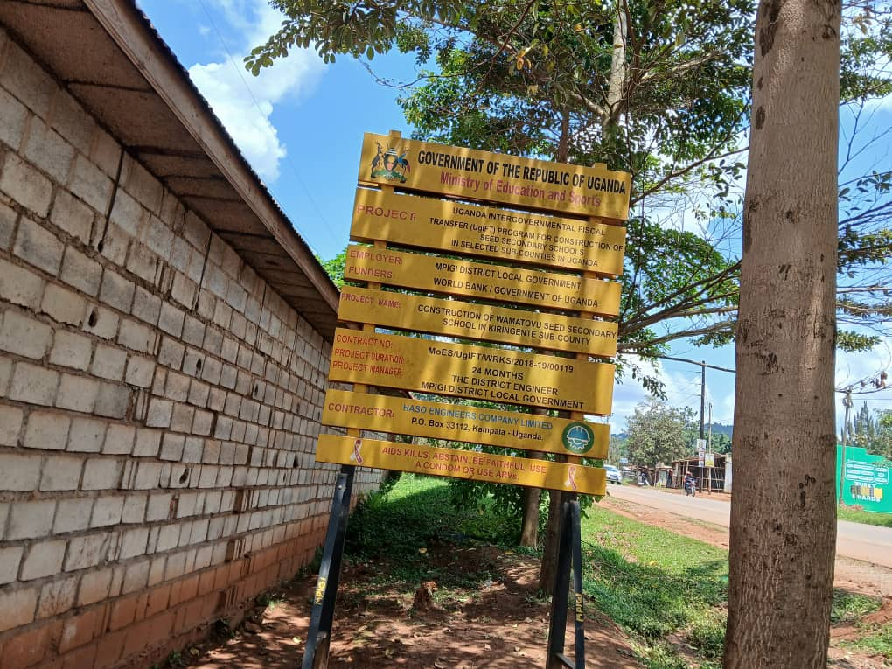 | 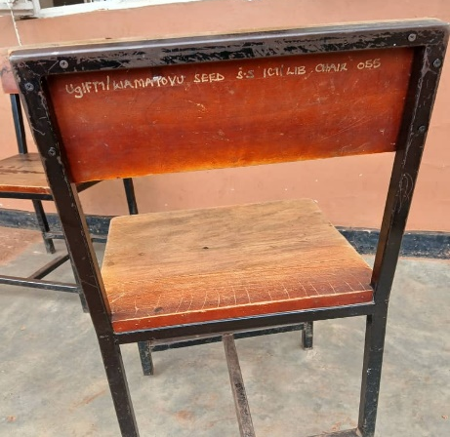 | 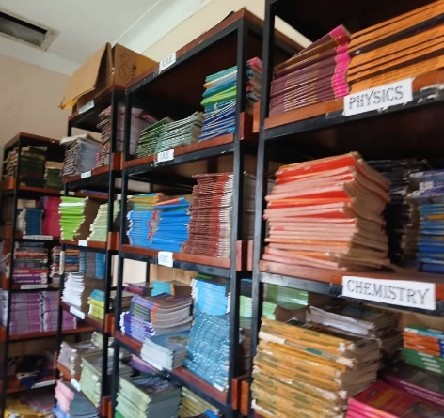
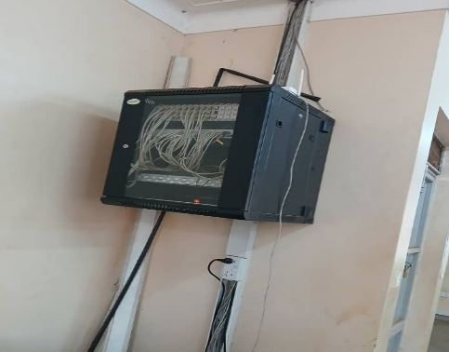 | 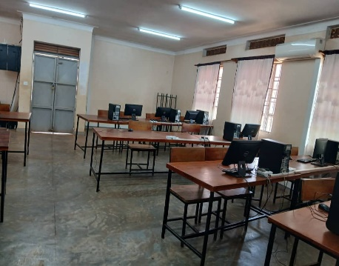 | 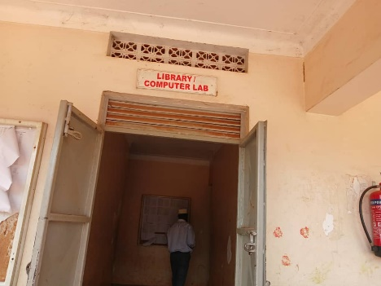
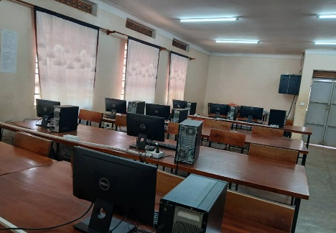 | 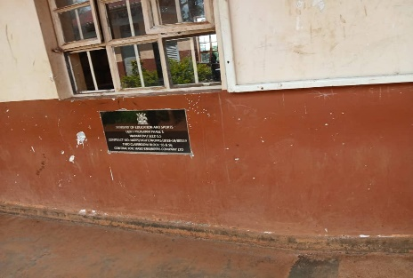 | 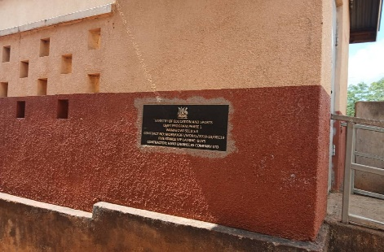
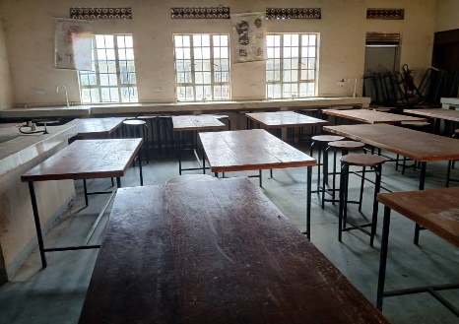 | 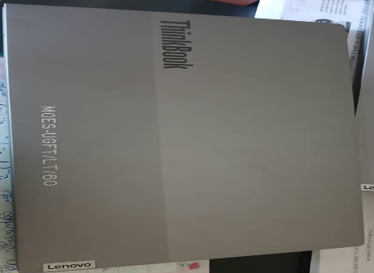 | 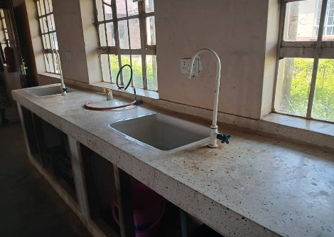
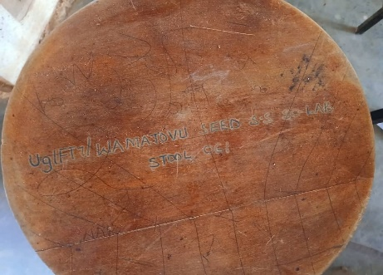 | 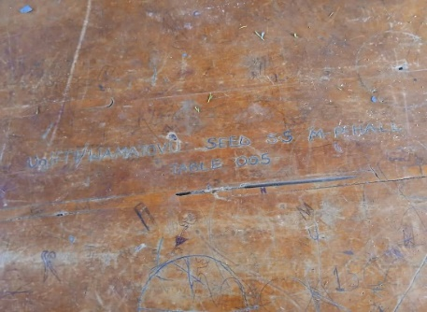 | 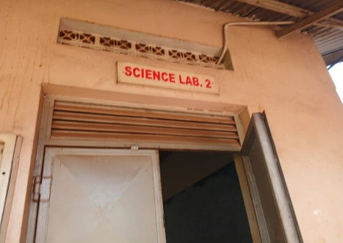
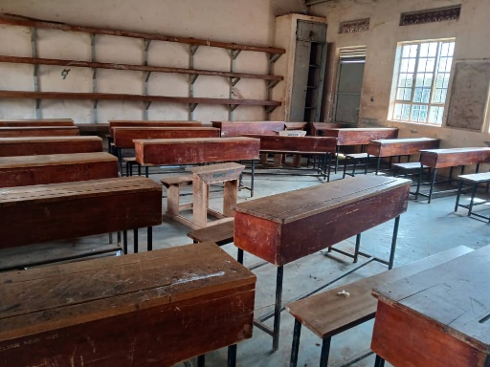 | 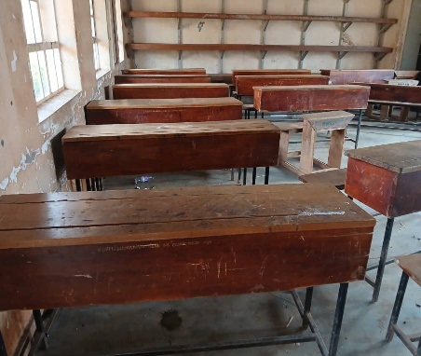 | 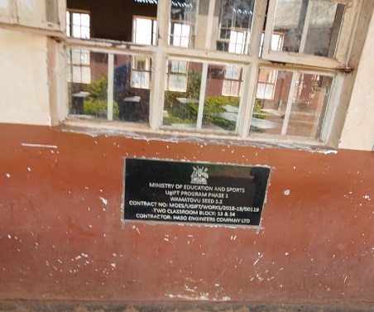
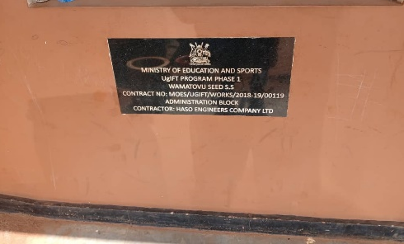 | 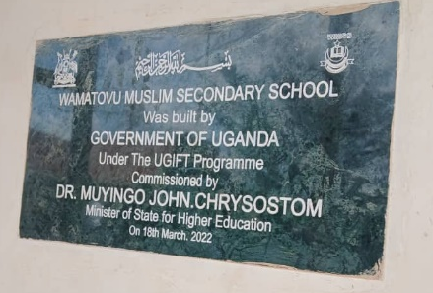 | 

